

Sam Del Rio
Actor / Stunt Performer
CONTACT: Big Fish Talent: 303-744-7170
Asgard Entertainment: 720-560-0981

YEAR
2011
2010
2009
2008
2008
2008
2008
2007
2006
2006
2005
2005
2004
2003
2003
2003
2003
2003
2000
2000
1999
1997
1996

PROJECT TITLE
Legacy of the Tengu
The Storyteller
Assassin’s Code
Easy Money (TV Series)
Gathering of Heroes
Best Ribs In Town
Furniture Row (Commercial)
Generosity
Portrait of Courage: Untold Story Flight 93
Shadow Walkers
Spotless
Leave’em Hang’in
Closure
Conquest: Weapons of the Ninja
Assault
After Dinner Chaser
Cop Movie
Virus
Dragon and the Hawk
Amends
Batman Forever Live Show
Tiger Street
3 Ninjas: High Noon At Mega Mountain

POSITION
Domino (Principle)
Solider (stunts)
Paul (Stunt Double)
Campus Cop
Jeris (Principle)
Stunt Double
Principle
Fight Coordinator
Terrorist/ FightCoordinator
Infected Guard / Stunts
Firearms Handler
Lucky / Stuntman
WWII Soldier
Stuntman
Stuntman
Stuntman
Stunt Double
Stuntman
Aveer (Principle)
Stuntman
Robin (Principle)
Styx (Principle)
Stuntman (uncredited)



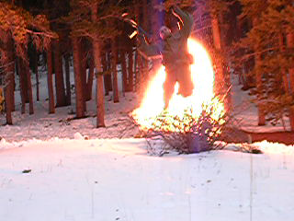

PERSONAL STATISTICS
STUNT SKILLS
Fight Choreography, Air Ram, Ratchet, Flying Harness, Rappelling, Tumbling, HighFalls, Partial Burns, Breakaways, Stairfalls, Precision Driving, Horsemanship, Firearms, Exotic Weapons, Motorcycles..
Height | 5’7”
Weight | 180
Eyes | Brown
Hair | Black
Waist | 34
Inseam | 32
Shoe | 9 1/2
Coat | 42 short
Hat | Med
Shirt | 16 32/33

SPECIAL SKILLS
Law Enforcement Training
CPR / AED Certified Instructor

ACCOMPLISHMENTS / AFFILIATIONS
2nd degree Black Belt Tae Kwon Do
1st degree Black Belt in Ninjutsu

PERSONAL STUNT GEAR
All general pads, Squib shield, Bullet proof vest, Jerk Harness, Skid shorts, Burn suit, Flying shorts

